Read each question carefully and use the link to find the answers. Write your answers in a Word document. Title it Rome Hunt. Print out your answers when finished. If you do not think you will finish by the end of the hour, email the Word Document to yourself and finish at home.
The Founding of Rome
1. According to legend, who founded Rome? (Click on the link for their names to learn more.)
2. Who were their parents?
3. Who found these twins?
4. What did they disagree about that led to the death of one of them? Which twin built the city of Rome and on which hill? ____
History
5. The Romans believed that their city was founded in the year____.
6. Modern historians, though, believe it was the year _________.
7. Early Rome was governed by kings, but later developed self-rule by a council, known as the _______ which ruled over them. What type of government did Rome create? Why was this was this considered a “better” government than what they had before?
8. The greatest challenge to the Roman Republic was from the Carthaginians in Northern Africa. In what year did Rome destroy Carthage? ______
9. Look at this map of the whole Roman Empire. It no longer just was the peninsula of Italy. It included land from North Africa to areas of the British Isle. Name 7 of the countries listed on the map that were part of the Roman Empire.
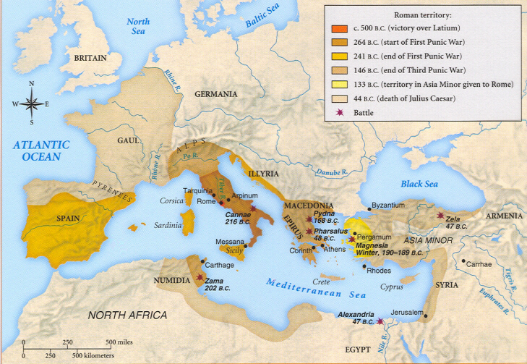

People
- List and describe the 5 levels of social class in ancient Rome.
- Read more about slaves. Who were usually slaves? Do a Google search and include a description of Gladiators and their role in society.

Death and Burial
12. Name the two forms of burial practiced by the Romans.
13. Where were people usually buried and why?
14. Why did they begin to use underground burial and what were these areas called?
- Who was the chief god in Ancient Rome? Describe this god.
- What kinds of games did Romans play?
- What three important ideas did Romans contribute to architecture?

